Skill Week – 1:
Creation of IAM User with Programmatic Access and Configuration of AWS Billing Alerts for Free Tier Usage

Successful Creation and Verification of AWS Budget (Zero_Budget)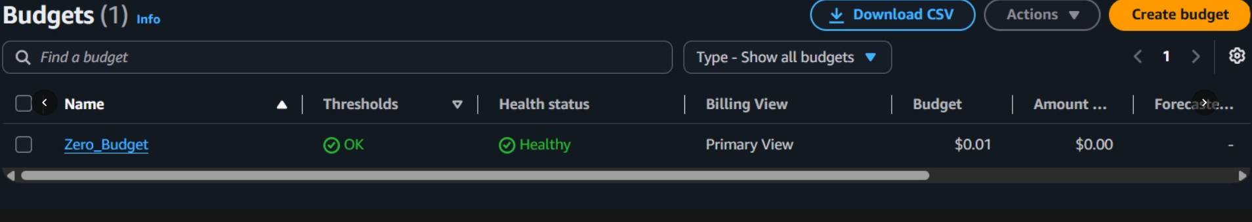
AWS Identity and Access Management (IAM) Dashboard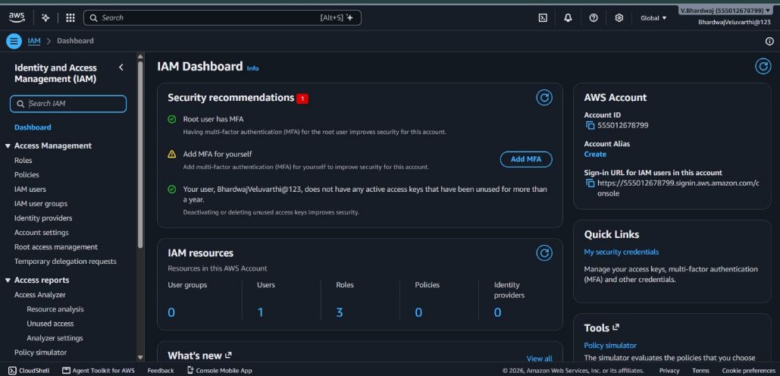
AWS Billing and Cost Management Dashboard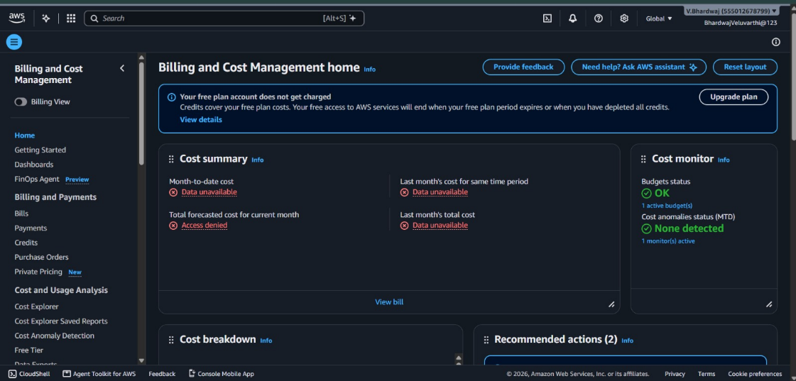
IAM Users Management – Accessing the User Creation Page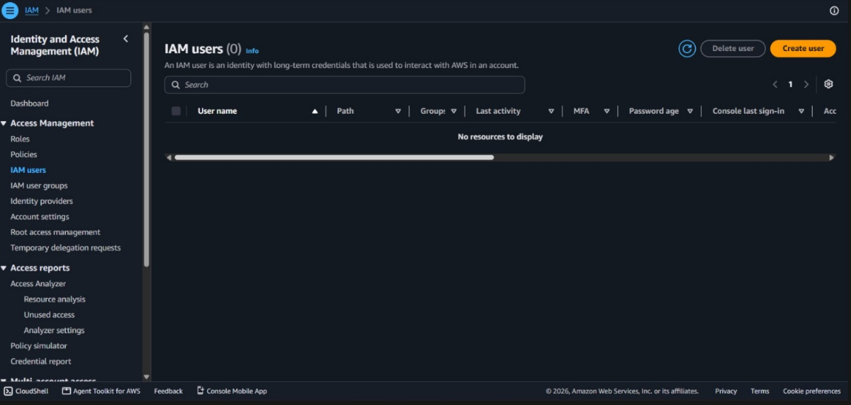
AWS Account Details and IAM User Sign-In URL

